Clustering London Tube Stations Based on Nearby Businesses for Advertising Purposes

Aims of the Project

This project is aimed at assisting advertising agencies identify at which groups of London Underground Stations (LUS) they should buy advertising space.

LUS rent wall space to advertising agencies. The advertising agencies want to ensure that their adverts are well targeted. The sort of businesses around a station tells them something about the type of people who are most likely to be transiting through a station and therefore what they might be interested in purchasing, eg if there is lots of pubs and other evening venues around a station music or alcohol adverts might be effective, and if there is a lot of parks and cafes, adverts for books might be more effective.

In order to reduce costs an advertising agency wants to buy space at a number of stations at one time. This project aims to cluster LUS together based on the surrounding businesses to help advertising agencies identify groups of stations where they should buy space (to get the bulk buying discount).

Data Requirements

Two datasets are required for this project:

- The co-ordinates of London Underground Stations. This information can be found in a table at https://wiki.openstreetmap.org/wiki/List_of_London_Underground_stations.

- The data from FourSquare about the types of businesses within a certain radius of the London Underground Stations.

Methodology:
Cleaning up the data

Data on London Underground Stations

The co-ordinates of the London Underground Stations can be scrapped from the webpage at:

https://wiki.openstreetmap.org/wiki/List_of_London_Underground_stations

Some of the cells however includes data that is not part of the co-ordinates - in some cells there is an error estimate. This was removed by converting the cell contents to a string, and then slicing the string to remove the additional information, and then converting the string back to a float for further processing.

Some stations are present in the table more than once, since they have multiple entrances. For the purposes of this project only one instance of each station is required, so only the first mention was kept. This was not believed to add error to the project because the stations were small compared to the radius we sought business information on. This processing created a list of 330 London Underground Stations

FourSquare

Since we had only a free developer account (no credit card number provided) we had to make sure that we had sufficient representative data without exceeding the limit of what was allowed. Trial and error revealed that seeking data for a radius of 500m around the station, limiting the return for each station to 30 provided a sufficiently rich data set without exceeding the daily limit.

Data Analysis
The London Underground Tube Stations were clustered using K means clustering using the relative frequency of the types of venues in the vicinity as the feature set. In order to determine the optimum number of clusters the ‘knee or elbow method’ was used. This entailed calculating the sum of squares for a range of values for the number of clusters (from 1 to 14 - the k value). Then plotting the value against the cluster size and identifying where the change in gradient was greatest aka the knee. The output graph is below:

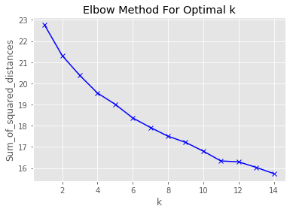

As can be seen the optimal k value is 11 (as determined by where the gradient changes most), aka the knee.

Results

The size of the clusters is summarised in the table below:

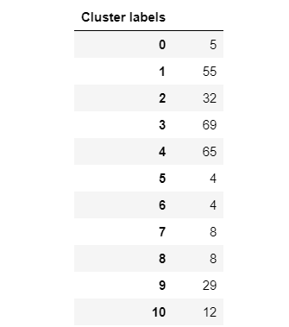

As can be seen the number of the stations in a cluster varies widely from between 4 and 69.

The location of the stations and the cluster they are in is contained in the image below:

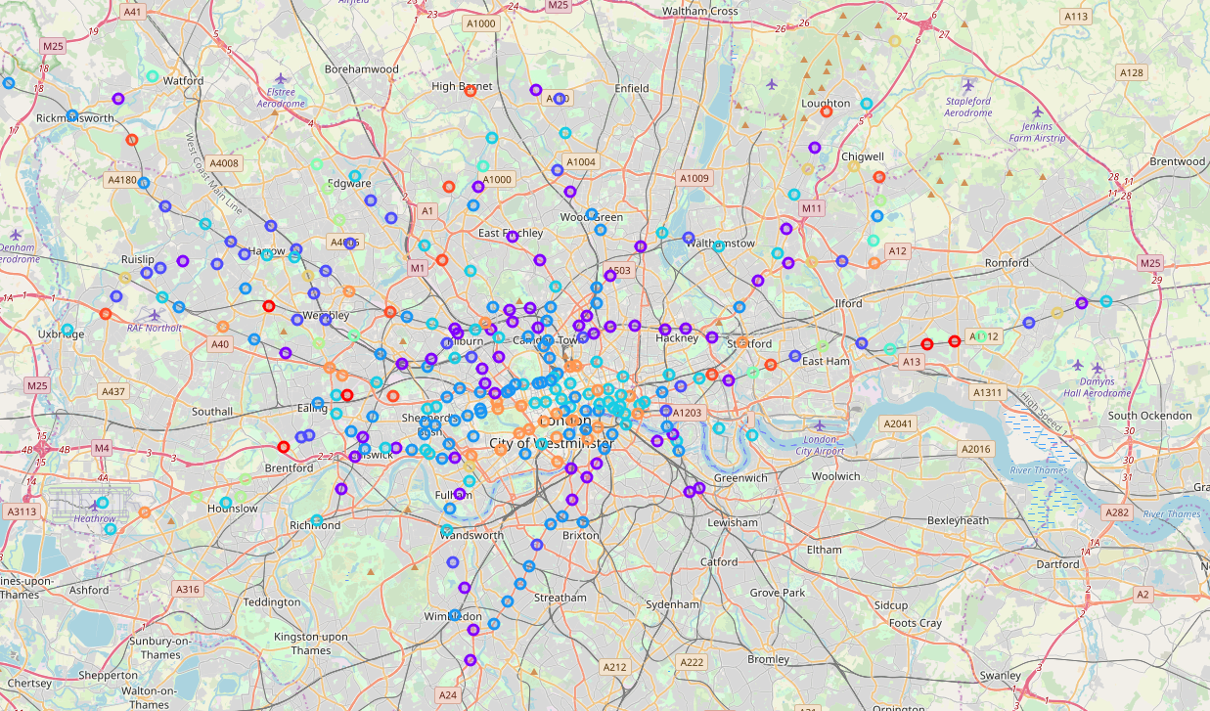

Cluster 0

The five most frequent venues in cluster 0 are illustrated in the graph below;
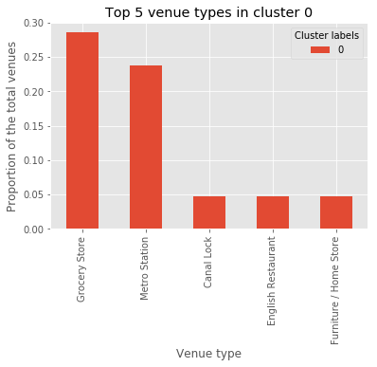

This cluster is characterised by the relative frequency of Grocery Store’s and Metro Stations.

Cluster 1

The five most frequent venues in cluster 1 are illustrated in the graph below;
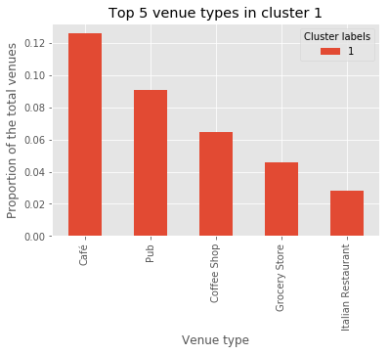

This cluster is characterised by the relative frequency of Cafes and pubs.

Cluster 2

The five most frequent venues in cluster 2 are illustrated in the graph below;
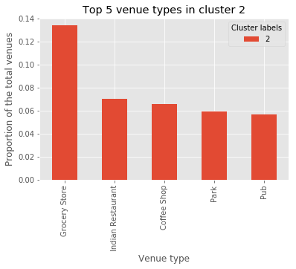

This cluster is characterised by the relative frequency of Grocery Stores.

Cluster 3

The five most frequent venues in cluster 3 are illustrated in the graph below;

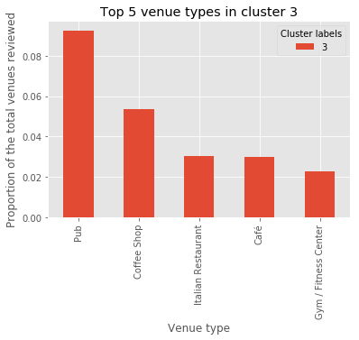

This cluster is characterised by the relative frequency of pubs.

Cluster 4

The five most frequent venues in cluster 4 are illustrated in the graph below;

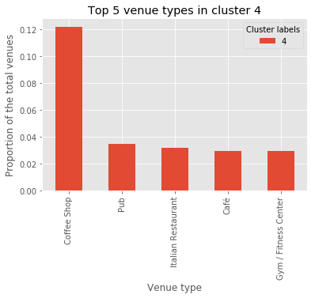

This cluster is dominated by the coffee shops.

Cluster 5

The five most frequent venues in cluster 5 are illustrated in the graph below;

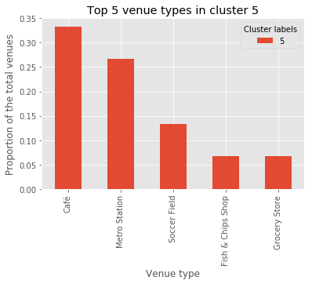

This cluster is dominated by a combination of Cafes and metro stations.

Cluster 6

The five most frequent venues in cluster 6 are illustrated in the graph below:

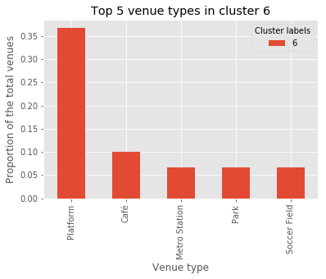

This cluster is dominated by platforms (ie metro station infrastructure).

Cluster 7

The five most frequent venues in cluster 7 are illustrated in the graph below:

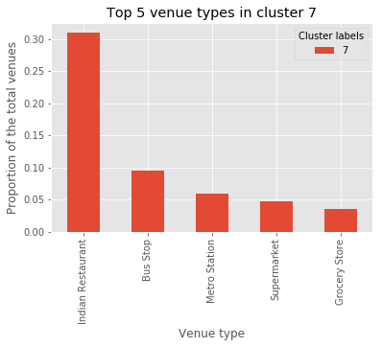

This cluster is dominated by Indian restuarants.

Cluster 8

The five most frequent venues in cluster 8 are illustrated in the graph below:

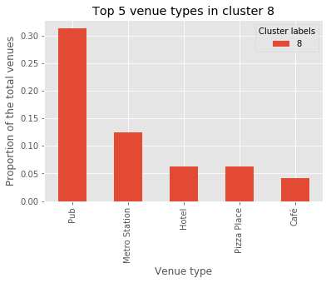

This cluster is dominated by pubs.

Cluster 9

The five most frequent venues in cluster 9 are illustrated in the graph below:

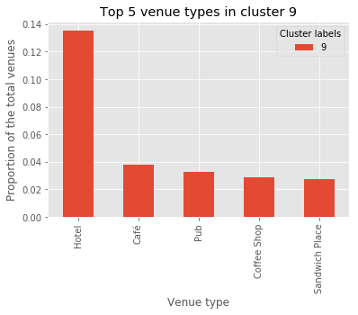

This cluster is dominated by hotels.

Cluster 10

The five most frequent venues in cluster 9 are illustrated in the graph below:

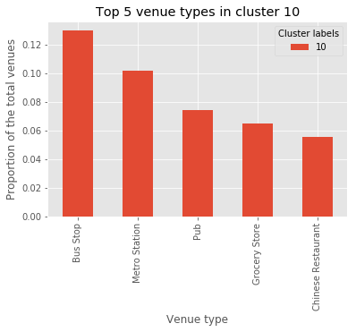

This cluster is dominated by a combination of bus and metro stations.

Discussion

Based on the above I recommend the following strategy for purchasing advertising space:

- Clusters 0 and 2 (37 stations in total) is characterised by a preponderance of grocery stores. I therefore propose that advertising space should be purchased in these for food adverts.

- Clusters 1, 3, 4, 5 and 8 (201 stations in total) are characterised by a relative abundance of pubs, coffees shops and cafes, ie venues for meeting friends, socialising and refreshments. I therefore propose that that advertising space be bought in these for alcohol, activities such as holidays, and dating applications.

- Cluster 6 and 10 (16 stations) is dominated by transport infrastructure. I therefore suggest that the advertising space at these places is used for adverts which require longer reading time, and for things people might want when traveling, eg books and snacks.

- Cluster 7 (20 stations) is dominated by Indian restaurants. I therefore propose that advertising space by purchased in these for foreign holidays and exotic food and drink.

- Cluster 9 (29 stations) is dominated by hotels. I therefore propose that advertising space be purchased for things people may want when away from home, eg network providers, restaurants and local visitor attractions.

Conclusion

This work confirms that distinct clusters can be found in the data about the relative frequency of venues around underground stations. To create more precise and accurate clusters though I recommend obtaining more data from FourSquare by not restricting the maximum number of venues returned for each station to 30. This will require the use of a credit card (outside the expenditure parameters of the current exploratory work).

If the advertising strategy as proposed in the discussion is pursued I recommend that the results should be reviewed in six months (balancing sunk costs against time to have an impact) to understand whether there is evidence that it has worked. This evidence might be collected by obtaining feedback from the companies we place the adverts for about whether they have noticed any changes, or interviewing a sample of station users.

I recommend that the model be recalculated every year since within this timescale there might have been sufficient change in the types of venues around a station to make a difference to the clustering.

Grant Hall
22 February 2019

